AHAMMED NAFIL J

251901006

COMPUTER NETWORKS

Ex.No.1 | Study of various Network commands used in Linux and Windows: Hands-on practice of various network commands.
Date:
AIM: - To Study of various Network commands used in Linux and Windows

S.No | Command | Synopsis | Description | Sample Input | Sample Output
1 | arp -a | arp -a | Displays the ARP cache, showing the IP addresses and corresponding MAC  addresses of devices on the local network. | arp -a | Interface: 192.168.1.10 ---  0x7 Internet Address Physical Address Type 192.168.1.1 00-1a-  2b-3c-4d-5e dynamic
2 | hostname | hostname | Displays the hostname (computer name) of the local system. | hostname | DESKTOP-PC01
3 | ipconfig  /all | ipconfig /all | Displays complete TCP/IP  configuration, including IP address, subnet mask, gateway, DNS, DHCP,  and MAC address. | ipconfig /all | IPv4 Address : 192.168.1.10  Default Gateway : 192.168.1.1 DNS  Server : 8.8.8.8 DHCP Enabled : Yes
4 | nbtstat - a | nbtstat -a  <hostname> | Displays NetBIOS name table of a remote computer for troubleshooting NetBIOS over TCP/IP. | nbtstat -a DESKTOP-PC01 | NetBIOS Remote Machine Name Table Name Type Status DESKTOP-PC01 <00>  UNIQUE Registered
5 | netstat | netstat | Displays active TCP/IP  connections, listening ports, | netstat | Proto Local Address Foreign Address State TCP 192.168.1.10:49762

S.No | Command | Synopsis | Description | Sample Input | Sample Output
 |  |  | routing tables, and interface statistics. |  | 142.250.190.78:443  ESTABLISHED
6 | netstat - r | netstat -r | Displays the IP routing table of the local computer. | netstat -r | IPv4 Route Table Network Destination Netmask Gateway Interface
7 | nslookup | nslookup  <domain> | Queries the DNS server to obtain the IP address or DNS records of a domain. | nslookup www.google.com | Server: dns.google Address: 8.8.8.8 Name: www.google.com Address: 142.250.190.68
8 | pathping | pathping  <hostname/IP> | Combines the features of ping and tracert to trace the route and measure packet loss at each hop. | pathping www.google.com | Tracing route to www.google.com Computing statistics... Hop  1 192.168.1.1 Hop  2 10.0.0.1 Packet  Loss: 0%
9 | ping | ping  <hostname/IP> | Tests connectivity between the local computer and another host using ICMP Echo Request and Reply messages. | ping www.facebook.com | Pinging www.facebook.com [157.240.22.35]  with 32 bytes of data: Reply from 157.240.22.35:  bytes=32 time=25ms TTL=54
10 | route | route print | Displays or modifies the IP routing table. It is commonly used to view or configure static routes. | route print | IPv4 Route Table Active Routes: Network Destination Netmask Gateway Interface

Some important Linux networking commands

S.No | Command | Synopsis | Description | Sample Input | Sample Output
1 | ip | ip <OPTIONS>  <OBJECT> <COMMAND> | Displays and manages IP addresses, routing tables, and network interfaces. | ip address show | 2: eth0: <UP,BROADCAST,RUNNING>  inet 192.168.1.100/24 brd 192.168.1.255 scope global eth0
2 | ip address add | ip address add  <IP>/<Prefix> dev  <Interface> | Assigns an IP address to a network interface. | ip address add 192.168.1.254/24  dev eth0 | Assigned 192.168.1.254/24 to eth0 successfully.
3 | ip address del | ip address del  <IP>/<Prefix> dev  <Interface> | Removes an IP address from a network interface. | ip address del 192.168.1.254/24  dev eth0 | Deleted 192.168.1.254/24 from eth0.
4 | ip link set up | ip link set  <Interface> up | Brings the network interface online. | ip link set eth0 up | Interface eth0 is UP.
5 | ip link set down | ip link set  <Interface> down | Brings the network interface offline. | ip link set eth0 down | Interface eth0 is DOWN.
6 | ip link set promisc on | ip link set  <Interface> promisc on | Enables promiscuous mode on the interface. | ip link set eth0 promisc on | Promiscuous mode enabled on eth0.
7 | ip route add default | ip route add default via  <Gateway> dev  <Interface> | Adds the default gateway for all outgoing traffic. | ip route add default via 192.168.1.254  dev eth0 | Default route added successfully.
8 | ip route add | ip route add  <Network> via  <Gateway> | Adds a static route through a gateway. | ip route add 192.168.1.0/24  via 192.168.1.254 | Route added successfully.
9 | ip route add (Direct Route) | ip route add  <Network> dev  <Interface> | Adds a direct route through a network interface. | ip route add 192.168.1.0/24  dev eth0 | Route added via eth0.
10 | ip route delete | ip route delete  <Network> via  <Gateway> | Deletes a static route. | ip route delete 192.168.1.0/24 | Route deleted successfully.

S.No | Command | Synopsis | Description | Sample Input | Sample Output
 |  |  |  | via 192.168.1.254
11 | ip route get | ip route get  <Destination IP> | Displays the route used to reach a destination. | ip route get 10.10.1.4 | 10.10.1.4 via 192.168.1.254 dev  eth0 src 192.168.1.100
12 | ifconfig | ifconfig | Displays and configures network interface parameters (deprecated in modern Linux). | ifconfig | eth0: flags=4163<UP,BROADCAST,RUNNING>  inet 192.168.1.100 netmask  255.255.255.0
13 | mtr | mtr <hostname/IP> | Combines Ping and Traceroute to analyze network paths. | mtr google.com | HOST: localhost Loss% Snt Last Avg Best Wrst StDev
14 | mtr -g | mtr -g <hostname> | Displays numeric IP addresses instead of hostnames. | mtr -g google.com | 192.168.1.1 → 142.250.190.78
15 | mtr -b | mtr -b <hostname> | Displays both hostnames and IP addresses. | mtr -b google.com | router.local (192.168.1.1)  google.com (142.250.190.78)
16 | mtr -c | mtr -c <count>  <hostname> | Sends a specified number of probes. | mtr -c 10 google.com | 10 probes completed successfully.
17 | tcpdump - D | tcpdump -D | Lists all available network interfaces. | tcpdump -D | 1.eth0 2.lo 3.wlan0
18 | tcpdump | tcpdump -i  <Interface> | Captures packets on a network interface. | tcpdump -i eth0 | Listening on eth0...
19 | tcpdump - c | tcpdump -i  <Interface> -c  <count> | Captures a specified | tcpdump -i eth0  -c 10 | 10 packets captured.

S.No | Command | Synopsis | Description | Sample Input | Sample Output
 |  |  | number of packets.
20 | tcpdump host | tcpdump -i  <Interface> host  <IP> | Captures traffic to and from a specific host. | tcpdump -i eth0 host 8.8.8.8 | Captured packets to/from 8.8.8.8.
21 | tcpdump src host | tcpdump -i  <Interface> src host <IP> | Captures packets originating from a specific host. | tcpdump -i eth0 src host 8.8.8.8 | Source packets from 8.8.8.8 displayed.
22 | tcpdump dst host | tcpdump -i  <Interface> dst host <IP> | Captures packets destined for a specific host. | tcpdump -i eth0 dst host 8.8.8.8 | Destination packets to 8.8.8.8 displayed.
23 | tcpdump net | tcpdump -i  <Interface> net  <Network>/<Prefix> | Captures traffic from a specified network. | tcpdump -i eth0 net 10.1.0.0/24 | Packets from network 10.1.0.0/24 displayed.
24 | tcpdump port | tcpdump -i  <Interface> port  <Port> | Captures traffic on a specific port. | tcpdump -i eth0 port 53 | DNS packets captured.
25 | tcpdump host and port | tcpdump -i  <Interface> host  <IP> and port  <Port> | Captures traffic for a specific host and port. | tcpdump -i eth0 host 8.8.8.8 and  port 53 | DNS traffic with host 8.8.8.8 displayed.
26 | tcpdump port not | tcpdump -i  <Interface> port not <Port1> and not <Port2> | Captures all traffic except the specified ports. | tcpdump -i eth0 port not 53 and not 25 | Traffic excluding ports 53 and  25 captured.
27 | ping | ping <hostname/IP> | Tests network connectivity using ICMP Echo Requests and Echo Replies. | ping google.com | 64 bytes from google.com: icmp_seq=1 ttl=117 time=10.5 ms
28 | ping -c | ping -c <count>  <hostname> | Sends a specified number of | ping -c 10 google.com | 10 packets transmitted, 10 received, 0% packet loss.

S.No | Command | Synopsis | Description | Sample Input | Sample Output
 |  |  | ICMP Echo Requests.

Configuring an Ethernet connection by using nmcli:

Step No. | Task | Command | Expected Result
1 | List all Network Manager connection profiles | nmcli connection show | Displays all available network connection profiles with their Name, UUID, Type, and Device.
2 | Create a new Ethernet connection profile  It is specifically an nmcli connection management command.  - nmcli → NetworkManager Command Line Interface  - connection → Manages network connection profiles.  - add → Creates a new connection profile. | nmcli connection add con-name Internal-LAN ifname enp1s0 type ethernet | Creates a new Ethernet connection profile named Internal-LAN.
3 | Rename an existing connection profile (Optional) | nmcli connection modify "Wired connection 1" connection.id Internal-LAN | Renames the existing connection profile to Internal-LAN.
4 | Display the current settings of the connection profile | nmcli connection show "Internal-LAN" | Displays interface name, autoconnect status, IPv4 and IPv6 configuration details.
5 | Configure IPv4 using DHCP | nmcli connection modify "Internal-LAN" ipv4.method auto | Configures the interface to obtain the IPv4 address

Step No. | Task | Command | Expected Result
 |  |  | automatically using DHCP.
6 | Configure a static IPv4 address | nmcli connection modify "Internal-LAN" ipv4.method manual ipv4.addresses 192.0.2.1/24 ipv4.gateway 192.0.2.254 ipv4.dns  192.0.2.200 ipv4.dns-search example.com | Assigns a static IPv4 address, gateway, DNS server, and DNS search domain.
7 | Configure IPv6 using SLAAC | nmcli connection modify "Internal-LAN" ipv6.method auto | Enables automatic IPv6 configuration using Stateless Address Autoconfiguration (SLAAC).
8 | Configure a static IPv6 address | nmcli connection modify "Internal-LAN" ipv6.method manual ipv6.addresses 2001:db8:1::fffe/64 ipv6.gateway 2001:db8:1::ffee ipv6.dns 2001:db8:1::ffbb ipv6.dns-search example.com | Assigns a static IPv6 address, gateway, DNS server, and search domain.
9 | Activate the connection profile | nmcli connection up Internal-LAN | Activates the Internal-LAN network connection profile.
10 | Verify the IP address configuration | ip address show enp1s0 | Displays the assigned IPv4 and IPv6 addresses of the enp1s0 network interface.
11 | Verify the IPv4 default gateway | ip route show default | Displays the configured IPv4 default gateway.
12 | Verify the IPv6 default gateway | ip -6 route show default | Displays the configured IPv6 default gateway.
13 | Verify the DNS configuration | cat /etc/resolv.conf | Displays the configured DNS servers and DNS search domain.
14 | Test network connectivity | ping <host-name-or-IP-address> | Sends ICMP Echo Requests to verify connectivity with the specified host.

Sample Verification Outputs
Verification Command | Sample Output
ip address show enp1s0 | inet 192.0.2.1/24  inet6 2001:db8:1::fffe/64
ip route show default | default via 192.0.2.254 dev enp1s0 proto static
ip -6 route show default | default via 2001:db8:1::ffee dev enp1s0 proto static
cat /etc/resolv.conf | search example.com nameserver 192.0.2.200 nameserver 2001:db8:1::ffbb
ping google.com | 64 bytes from google.com: icmp_seq=1 ttl=117 time=11.2 ms

Output:
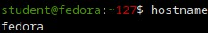

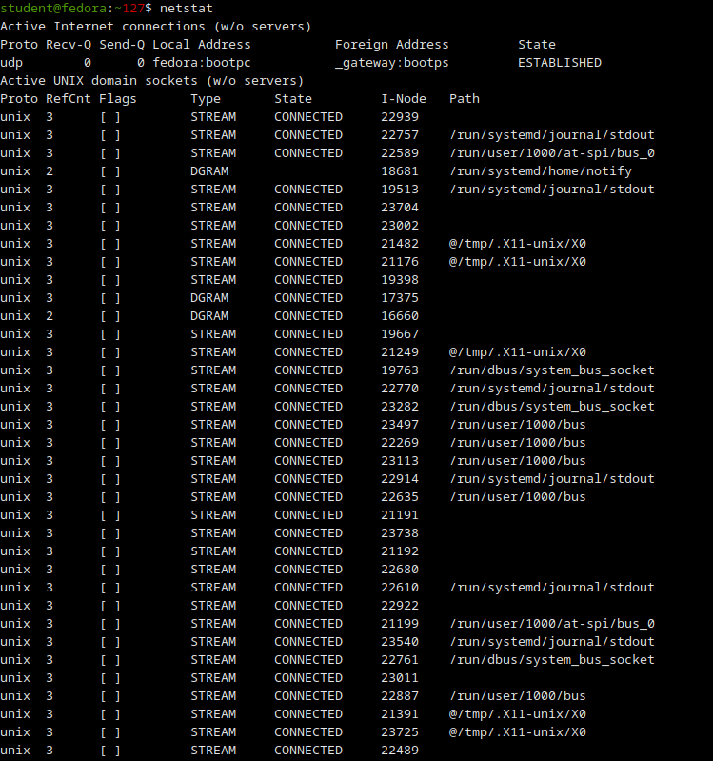
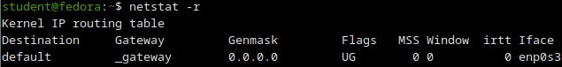

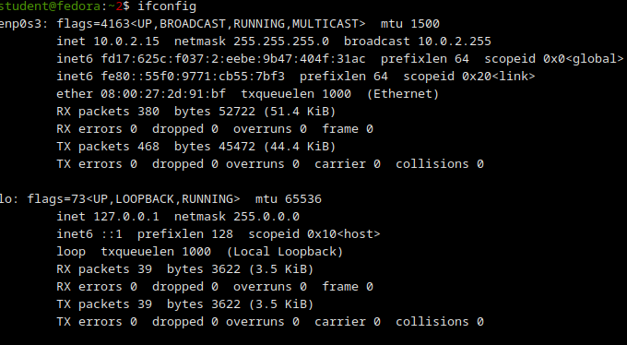
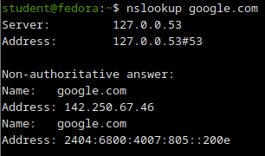
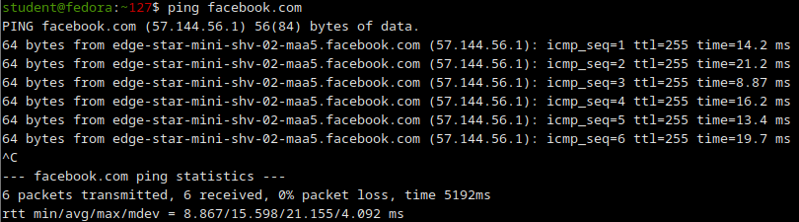

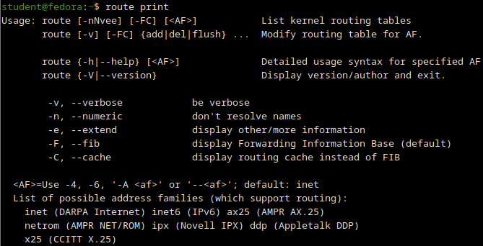
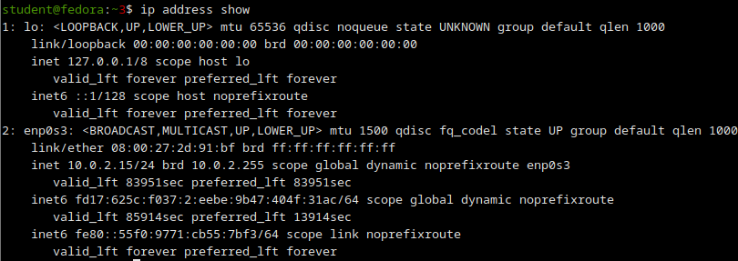

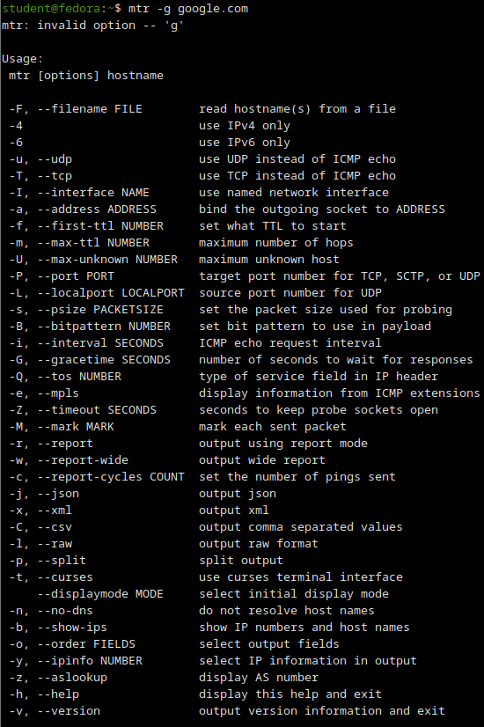

RESULT:
The various network commands in Linux and Windows were studied and executed successfully.

